INDEX

|  |  |  |
| --- | --- | --- |
| CHAPTERS | PARTICULAR | PAGE NO |
| CHAPTER 1 | INTRODUCTION | 3-7 |
| 1.1 | ABSTRACT |  |
| 1.2 | OVERVIEW OF DATABASE MANAGEMENT SYSTEM |  |
| 1.3 | PROBLEM STATEMENT |  |
| 1.4 | OBJECTIVE |  |
| 1.5 | TIMELINE |  |
| CHAPTER 2 | SYSTEM ANALYSIS | 8-12 |
| 2.1 | INTRODUCTION TO SYSTEM ANALYSIS |  |
| 2.2 | EXISTING SYSTEM |  |
| 2.3 | PROPOSED SYSTEM |  |
| 2.4 | HARDWARE REQUIREMENT |  |
| 2.5 | SOFTWARE REQUIREMENT |  |
| 2.6 | INTRODUCTION TO ASP.NET |  |
| 2.7 | INTRODUCTION TO JAVASCRIPT |  |
| 2.8 | INTRODUCTION TO ASPX PAGES |  |
| 2.9 | INTRODUCTION TO SQL SERVER |  |
| 2.10 | INTRODUCTION TO MASTER PAGES |  |
| CHAPTER 3 | METHODOLOGY | 13-18 |
| 3.1 | DATA FLOW DIAGRAM |  |
| 3.2 | TABLE STRUCTURE |  |
| CHAPTER 4 | RESULTS AND DISCUSSIONS | 20-30 |
| 4.1 | INDEX PAGE DESIGN |  |
| 4.2 | ABOUT PAGE DESIGN |  |
| 4.3 | CATEGORIES PAGE DESIGN |  |
| 4.4 | GALLERY PAGE DESIGN |  |
| 4.5 | CAREER PAGE DESIGN |  |
| 4.6 | CONTACT PAGE DESIGN |  |
| 4.7 | USER LOGIN PAGE DESIGN |  |
| 4.8 | REGISTRATION PAGE DESIGN |  |
| 4.9 | ADMIN LOGIN PAGE DESIGN |  |
| 4.10 | USER DASHBOARD PAGE DESIGN |  |
| CHAPTER 5 | CONCLUSION AND FUTURE ENHANCEMENT | 31-33 |
| 5.1 | CONCLUSION |  |
| 5.2 | FUTURE ENHANCEMENT |  |

CHAPTER 1

INTRODUCTION

* 1. ABSTRACT

In an increasingly digital world, the need for a reliable and comprehensive online directory service has become paramount. This project aims to develop an online platform that functions as an extensive local business directory and search engine, offering users a convenient and efficient means of finding local businesses, services, and products.

The platform provides users with the ability to search, discover, and connect with local businesses and services, enhancing the accessibility of relevant information. It offers an intuitive user interface with advanced search capabilities, user reviews and ratings, and features such as online bookings and reservations. Businesses are provided with advertising and promotional opportunities to improve their online visibility and connect with a broader customer base.

Some features include user registration and profiles, detailed business listings with contact information, secure user authentication, integration with mapping services, and a mobile app to extend accessibility. The project emphasizes data integrity, user security, and scalability to accommodate a growing number of users and businesses.

Key features:

* Satisfy the user requirements
* Be easy to understand by the user and operator
* Have a good user interface
* Be easy to modify
* Be expandable
* Have an adequate security control against the misuse of data
* Handle the error and exception satisfactory
* Be delivered on schedule within the budget.
  1. OVERVIEW OF DATABASE MANAGEMENT SYSTEM

A Database Management System (DBMS) is software that provides an organized and efficient way to store, retrieve, and manage data. It acts as an intermediary between users and the underlying database, ensuring data integrity, security, and accessibility.

The history of Database Management Systems (DBMS) is a journey that spans several decades, marked by significant technological advancements and the evolution of data management.

The concept of databases began in the 1960s when the need to organize and manage data for large organizations became apparent. Early database systems were hierarchical and network databases, such as IBM's Information Management System (IMS) and the CODASYL data model.

The 2010s saw the rapid expansion of NoSQL databases like MongoDB, Cassandra, and Redis, which addressed the need for flexible data storage and retrieval.

In 2020 Cloud-based DBMS solutions became prevalent, allowing organizations to deploy, manage, and scale databases with ease. The integration of AI and machine learning into DBMS platforms started to improve data analysis and decision-making capabilities.

Popular database management systems include:

Relational DBMS: MySQL, PostgreSQL, Oracle Database, Microsoft SQL Server.

NoSQL DBMS: MongoDB, Cassandra, Redis, Couchbase.

NewSQL DBMS: Google Spanner, CockroachDB.

In-memory DBMS: Redis, Memcached.

Easy-Go is an Indian local search service that provides users with information about local businesses, products, and services. While Easy-Go does not publicly disclose the specifics of their database management system, they likely use a robust and scalable database system to manage the vast amount of data they collect and maintain.

Easy-Go likely uses a relational database management system (RDBMS) to store structured data, such as business listings, user reviews, contact information, and geographical data. They might also use SQL Server databases for specific use cases where unstructured or semi-structured data is involved.

Create a user registration form that collects essential information. This typically includes a username, email address, password, and sometimes additional details like name, age, and contact information.

A contact database is a structured collection of information about individuals, organizations, or entities that an individual, business, or organization may need to contact for various purposes. This database is typically used for managing and maintaining contact information, enabling efficient communication and interaction.

* 1. PROBLEM STATEMENT

In short, Easy-Go’s primary challenges and problem areas may include ensuring accurate and complete business listings, enhancing user engagement, staying competitive, scaling and optimizing performance, focusing on mobile accessibility, monetization strategies, data security and privacy, machine learning for personalization, content moderation, legal compliance, customer support, user trust, and business partner relations. These challenges may evolve over time as the company continues to adapt and innovate in the local search and business listing space.

* 1. OBJECTIVE

Easy-Go is an Indian local search service that connects users with local businesses and services. Its objectives may include:

* **Connect Users and Businesses**: To provide a platform that connects users seeking local products and services with businesses offering them.
* **Comprehensive Listings**: To maintain an extensive and up-to-date database of business listings, ensuring that users have access to a wide range of choices.
* **User Engagement**: To keep users engaged by providing a user-friendly interface, accurate search results, and personalized recommendations.
* **Data Quality**: To ensure the accuracy and completeness of business information, user reviews, and other data on the platform.
* **Data Security**: To protect user data and maintain user trust by implementing robust data security and privacy measures.
* **Customer Support**: To provide efficient and responsive customer support to address user and business concerns.
* **User Trust and Reputation**: To build and maintain user trust and a positive reputation in the local search industry.
* **Innovation and Adaptation**: To continuously innovate and adapt to evolving market dynamics, technological advancements, and user preferences.

1.5 TIMELINE

|  |  |
| --- | --- |
| Weeks | Activity |
| 1. | We brushed up our prior knowledge of C#, JAVA and JavaScript. Started to learn about ASP.net, SQL Server (for backend) and Html, C#, JavaScript (for frontend) of our Web App. We also made an ER diagram about the basic structure of the application. |
| 2. | We did the basic coding for the structure of the application using Visual Studio. Started reading the material provided by the company and research papers on Web development. |
| 3. | Familiarization with existing projects, technologies, and tools used within the organization. Studied about Aspx pages, .cs Files and SQL Server. In ASP.NET, a master page is a template that contains the common structure of the pages in your application. |
| 4. | Increased involvement in ongoing projects, collaboration with team members, and hands-on coding experience to create homepage, contact, login and registration page, admin-page, |
| 5. | Create a database and define the necessary tables to organize your data logically. Use the database connection details to establish a connection in your server-side code. Created more page’s categories, about, career, contact pages. |
| 6. | Conduct thorough testing of the website for functionality and compatibility.  Identify and fix bugs. Deploy the website to a staging environment for final testing. Make necessary refinements based on feedback. |
| 7. | Monitor website performance. Provide support for any issues that may arise post-launch. Gather feedback for future improvements. |

CHAPTER 2

SYSTEM ANALYSIS

2.1 INTRODUCTION TO SYSTEM ANALYSIS

A system analysis of Easy-Go involves an in-depth examination of the components, processes, and functionalities of the Easy-Go platform. This analysis helps understand how the system operates, identifies its strengths and weaknesses, and provides insights into potential improvements.

User can be classified into two types based on their knowledge of the product that suit their needs. They can be classified as user who know about the product that would satisfy their needs and user who have to figure out the product that would satisfy their needs. User who knows about the product should be able to find the product easily with the click of a button. Such user can search for the product by using the category section as the search term. Users who have to figure out the product that would satisfy their needs could use a search term to find a list of products and then should be able to filter the results based on various sections like product type, name, address, rating, phone etc.

System Components:

User Interface: Easy-Go's web and mobile interfaces provide users with a user-friendly way to search for local businesses, products, and services.

Database: Easy-Go maintains a vast database of business listings, user reviews, and other data.

Search Engine: The search engine is a crucial component that enables users to find relevant business listings.

Data Processing: Data processing components handle data validation, normalization, and storage.

User Accounts and Profiles: Easy-Go manages user accounts, preferences, and profiles.

Data Management:

Easy-Go must continuously update, validate, and maintain its database to ensure accurate and comprehensive business listings.

Content moderation tools are essential to manage user-generated content, including reviews and ratings.

2.2 System feasibility

System feasibility refers to the assessment of whether a proposed system or project is viable, practical, and worth pursuing. It involves evaluating various aspects to determine if the project is feasible and if it aligns with the organization's goals and resources. System feasibility typically encompasses three key areas:

Technical Feasibility:

To deploy the application, the only technical aspects needed are mentioned below: Operating Environment Win 2000 / XP/win 7/win 10/win 11

Front end – C#, HTML, CSS and JavaScript

Database SQL Server 2013

Internet Browser: chrome, Edge

Economic feasibility:

Economic feasibility is a financial assessment that determines if a proposed project or system is cost-effective and can provide a positive return on investment (ROI). It involves estimating costs, analyzing benefits, and evaluating whether the project is financially viable and aligns with the organization's objectives.

Behavioral feasibility:

Behavioral feasibility, also known as organizational or cultural feasibility, is an assessment of whether a proposed project or system can be successfully integrated into an organization's existing work culture and whether employees are likely to embrace and adapt to the changes. It focuses on the human and organizational aspects of a project.

SYSTEM REQUIREMENT

System requirements for a web project outline the necessary hardware, software, and technical specifications needed to develop, host, and maintain the web application.

Front End:

User interface: C#, HTML, CSS and JavaScript

Operating System: Microsoft Windows 7 or above

Web Browser: Chrome, Internet Explorer

Back End:

Programming language: Java/J2EE, JavaScript

Database: SQL SERVER

Application Server: SQL Server (2013) for server (localhost 8080)

.CS file for server-side scripting.

Visual Studio 2022 (Source Code Editor)

Hardware Requirements

The software should run on any sort of desktop or laptop environment, regardless of the operating system. Essential input/output devices are keyboards, mouse, and printers; nothing else is required but can be recommended if desired.

Processor: Pentium IV and above.

Hard Disk: 100 GB

RAM: 2-16 GB or above

Display Resolution: 1366 * 768 (1920*1080 Recommended) Other standard physical. devices like keyboard, mouse etc.

Other standard physical devices like keyboard, mouse etc.

Chapter 3

METHODOLOGY

The web development process involves several stages from conceptualization to deployment. Here's a general overview of the typical steps in the web development process:

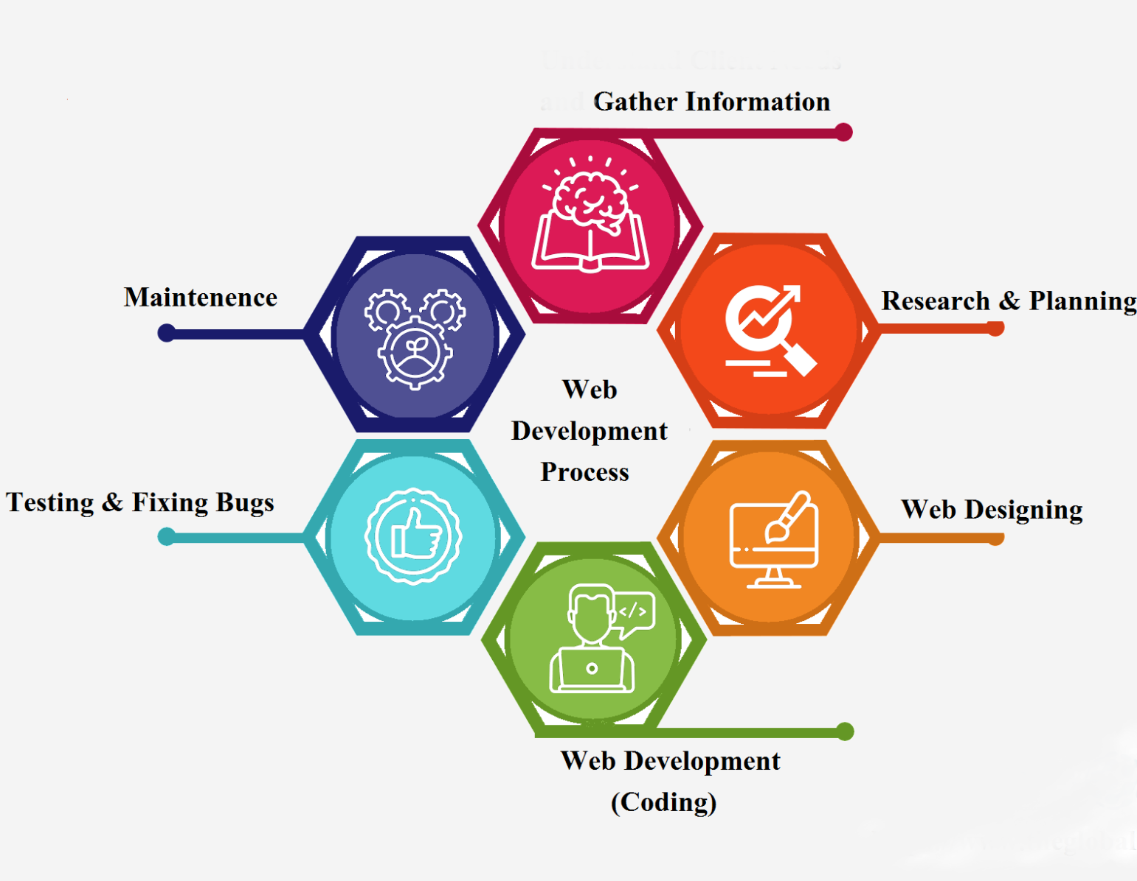

Define Objectives and Requirements:

Understand the purpose and goals of the website or web application.

Identify the target audience and their needs.

Gather specific requirements for functionality, design, and features.

Planning:

Create a project plan outlining tasks, timelines, and resources.

Define the technology stack, including the choice of programming languages, frameworks, and databases.

Plan for scalability, security, and performance optimization.

Design:

Develop wireframes or prototypes to visualize the layout and structure.

Create the user interface (UI) and user experience (UX) design.

Choose color schemes, fonts, and graphics that align with the brand.

Front-End Development:

Write HTML, CSS, and JavaScript code to build the user interface.

Use frameworks like ASP.net for interactive and dynamic elements.

Ensure responsive design for various devices and screen sizes.

Back-End Development:

Develop server-side logic and functionalities.

Choose a server-side programming language (e.g., SQL, MYSQL, SQL Server, SQL Workbench) and a framework (e.g., C#, ASP.net, ASP.net (Core), ASP.net (MVC).

Implement database interactions and data storage.

Database Development:

Design the database schema based on the application's data requirements.

Choose a database management system (e.g., MySQL, PostgreSQL, MongoDB) and set up the database.

Write queries for data retrieval, insertion, and modification.

Integration of Front-End and Back-End:

Connect the front-end and back-end components to enable data exchange.

Implement APIs (Application Programming Interfaces) for communication between the client and server.

Testing:

Conduct thorough testing, including unit testing, integration testing, and user acceptance testing.

Identify and fix bugs or issues.

Ensure cross-browser compatibility and responsiveness.

Deployment:

Choose a hosting platform (e.g., AWS, Heroku, DigitalOcean) for deployment.

Set up server configurations and deploy the web application.

Configure domain settings and ensure SSL for security.

Monitoring and Maintenance:

Implement monitoring tools to track performance, errors, and user behavior.

Regularly update and maintain the website or application to address security vulnerabilities and improve features.

Provide ongoing support and address user feedback.

SYSTEM DESIGN

System design is the process of defining and specifying how a software system will be structured, how its components will interact, and how it will meet its functional and non-functional requirements. This phase of software development follows system analysis and precedes implementation and coding. It involves creating a detailed blueprint or plan for the software system.

Entity- Relationship Diagram

An Entity-Relationship Diagram (ERD) is a visual representation that illustrates the entities, attributes, and relationships between data entities within a database or information system. ERDs are commonly used in database design to help model the structure and organization of data.

ERDs provide a visual way to represent the logical structure of a database and are an essential tool in the database design process. They help in understanding the relationships between data entities and serve as a blueprint for creating database schemas and tables in a database management system.

3.1 DATA FLOW DIAGRAM

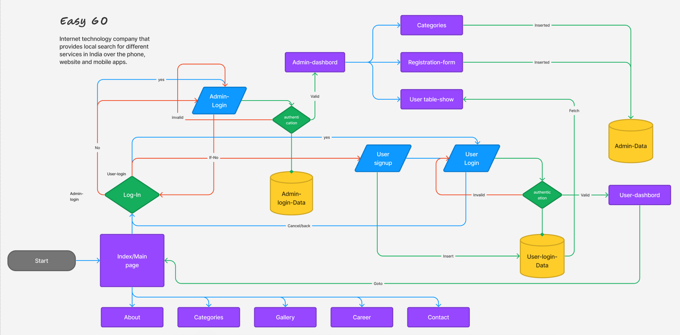

Figure: basic structure of Easy-go

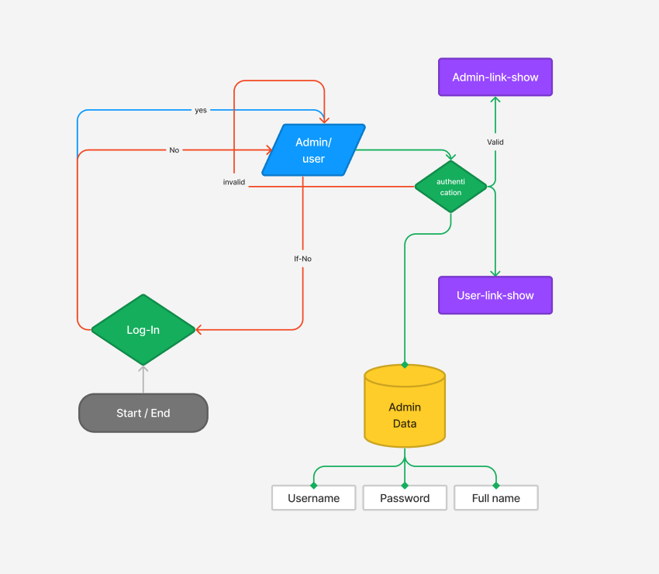

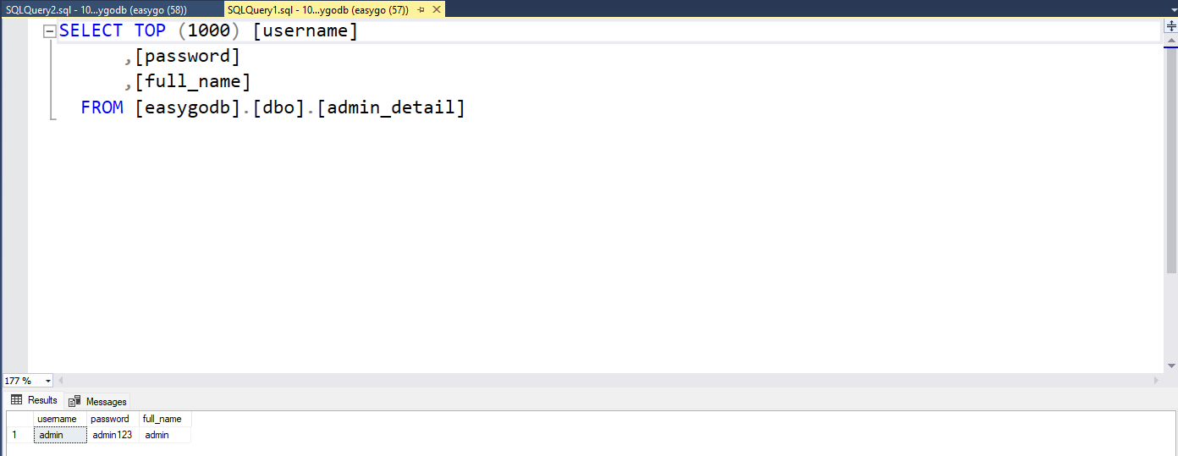

Figure: ER diagram and table of Admin

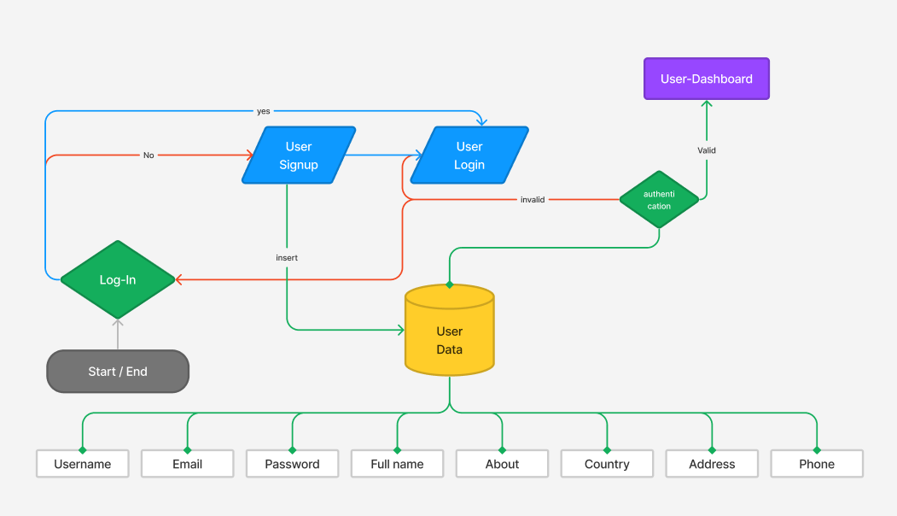

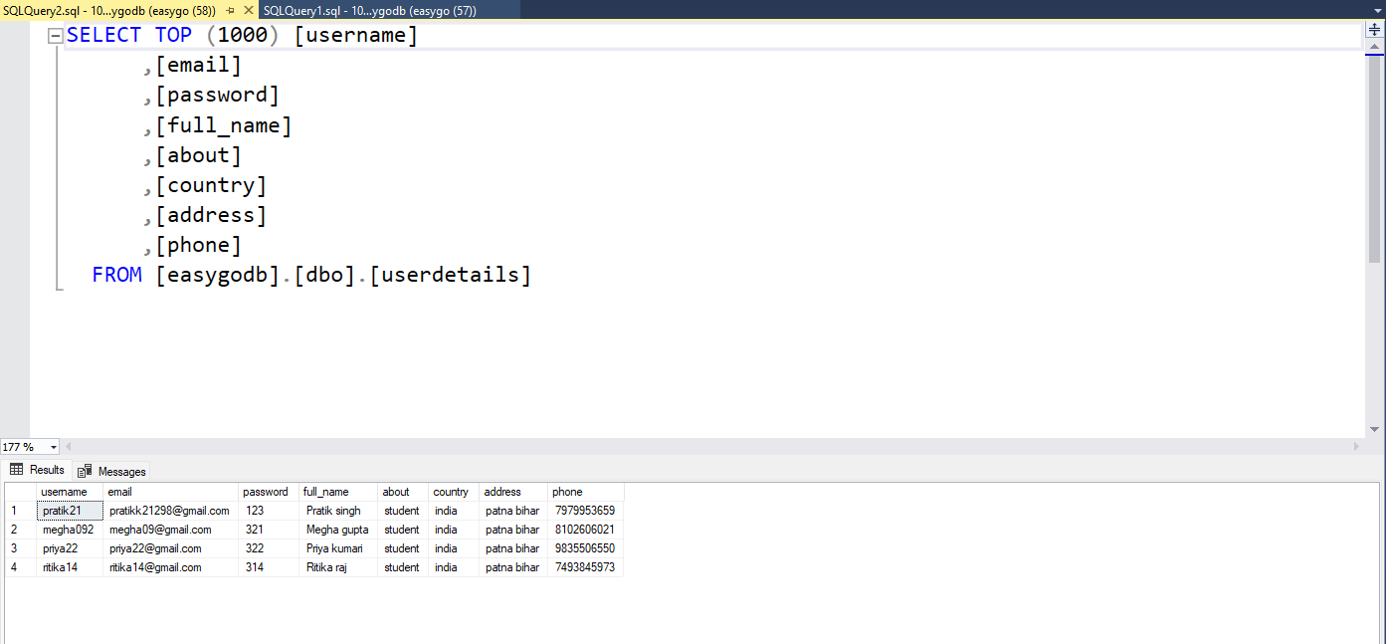

Figure: ER diagram and table of User

CHAPTER 4

RESULTS AND DISCUSSIONS

# Screenshot after the Deployment

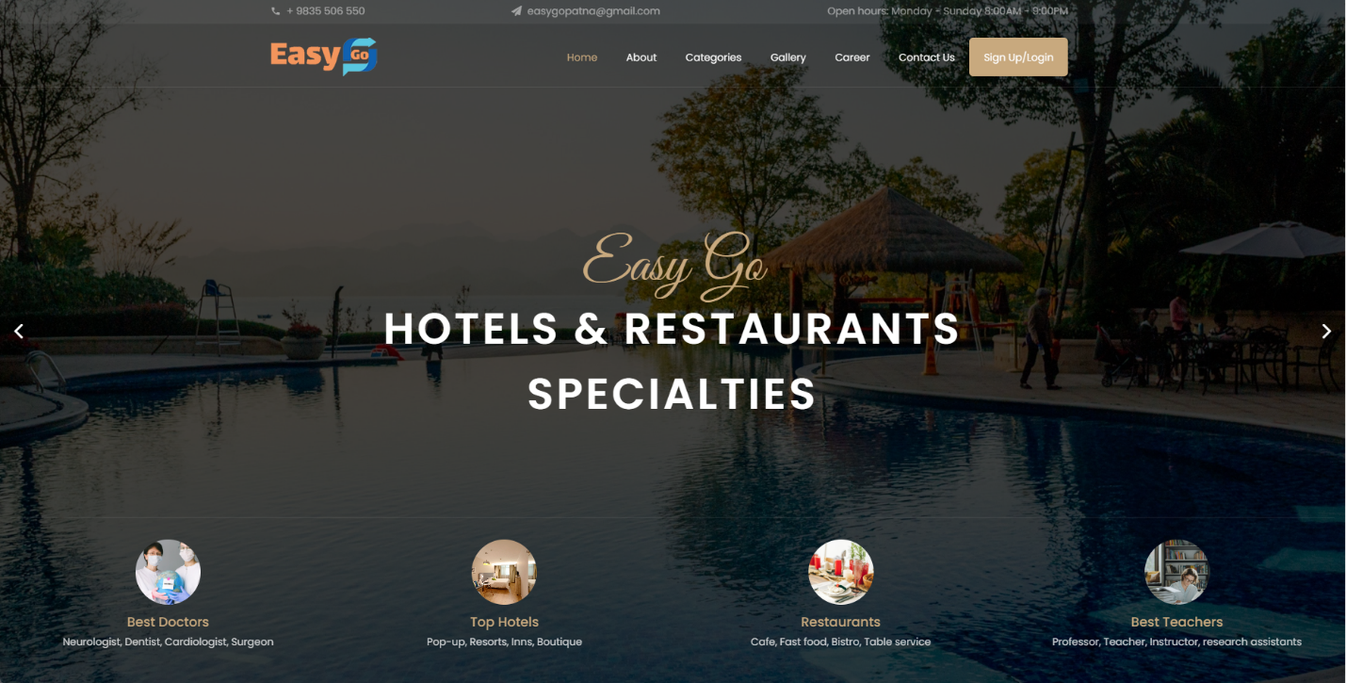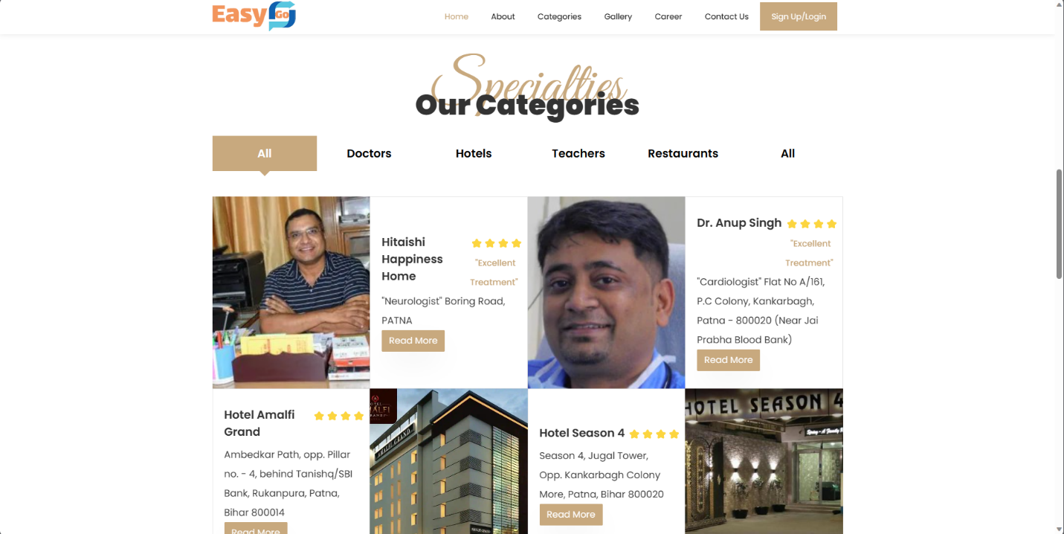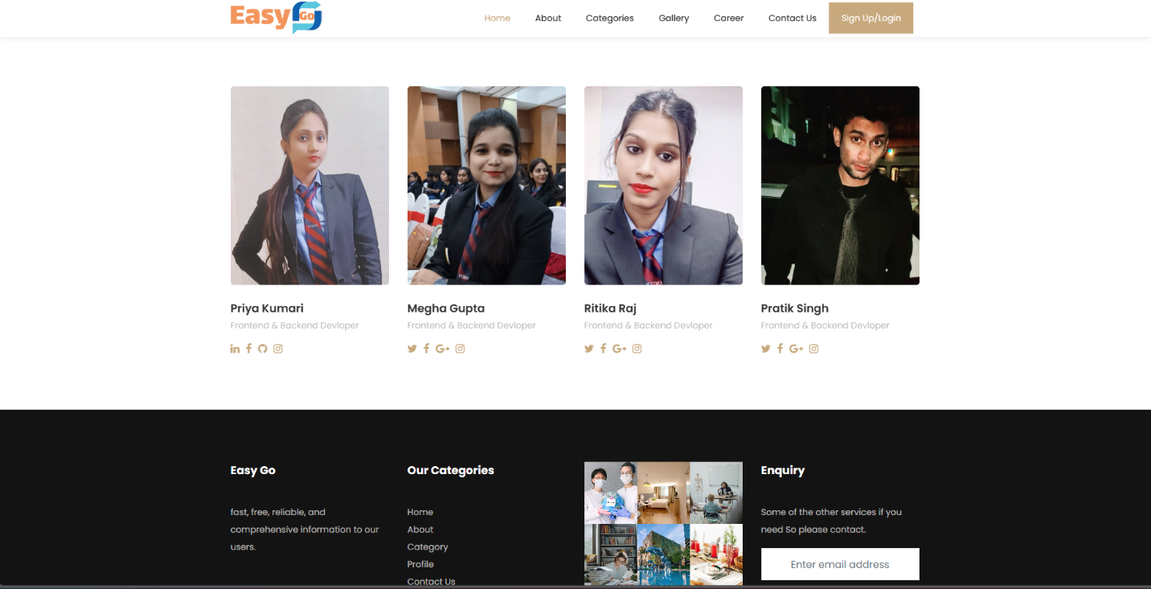

4.1 Figure: Index page of the Easy go

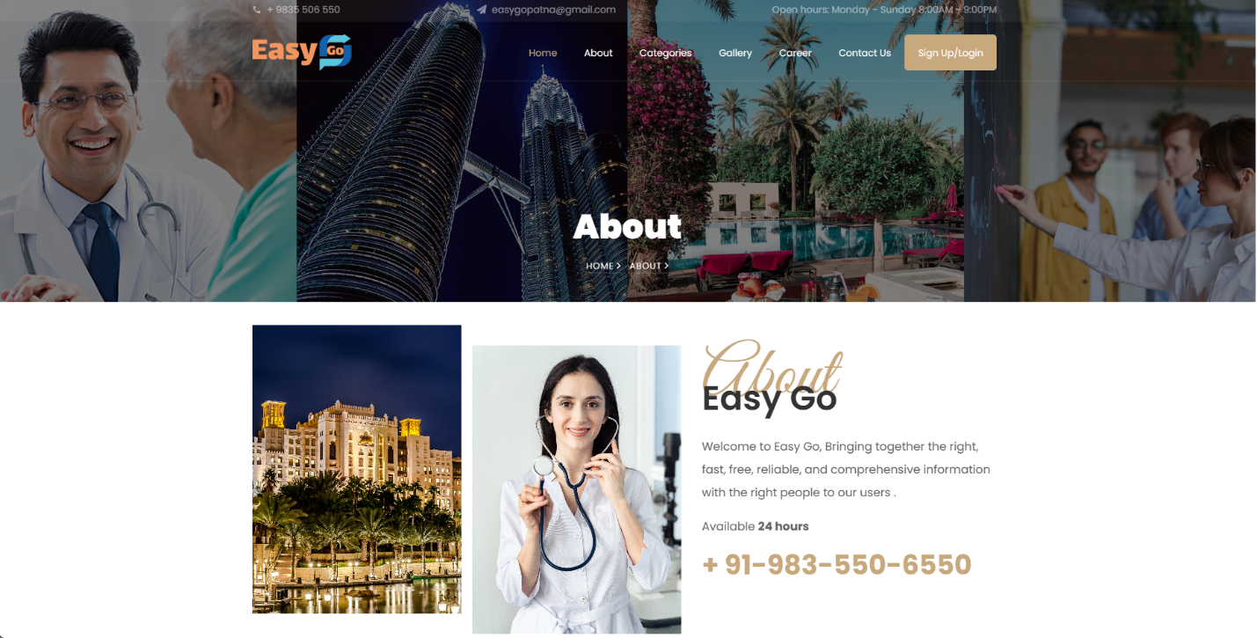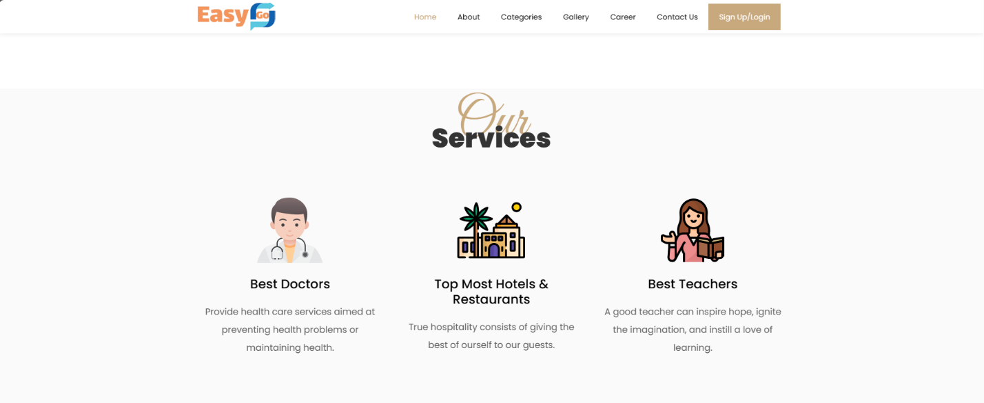

4.2 Figure: About page of Easygo

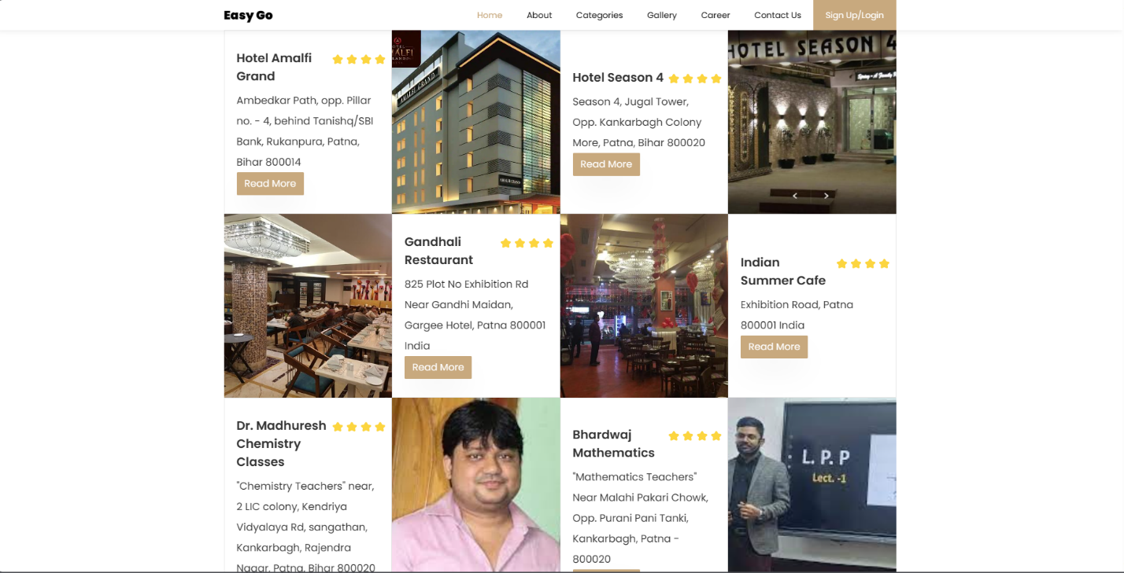

4.3 Figure: Categories page of Easygo

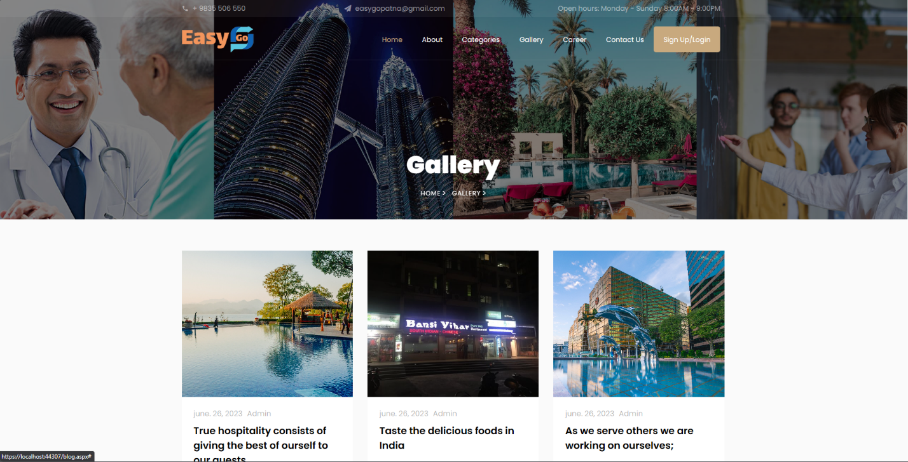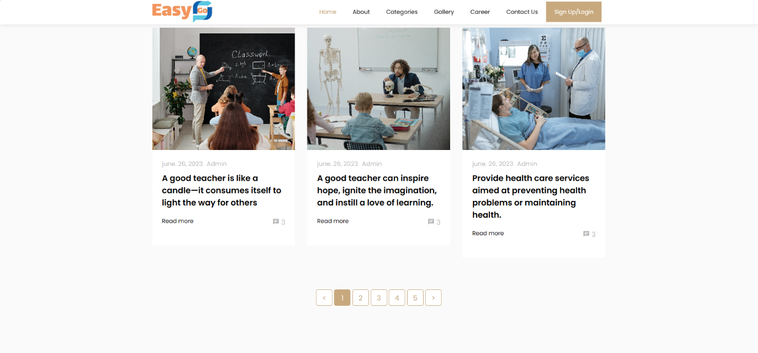

4.4 Figure: Gallery page of Easygo

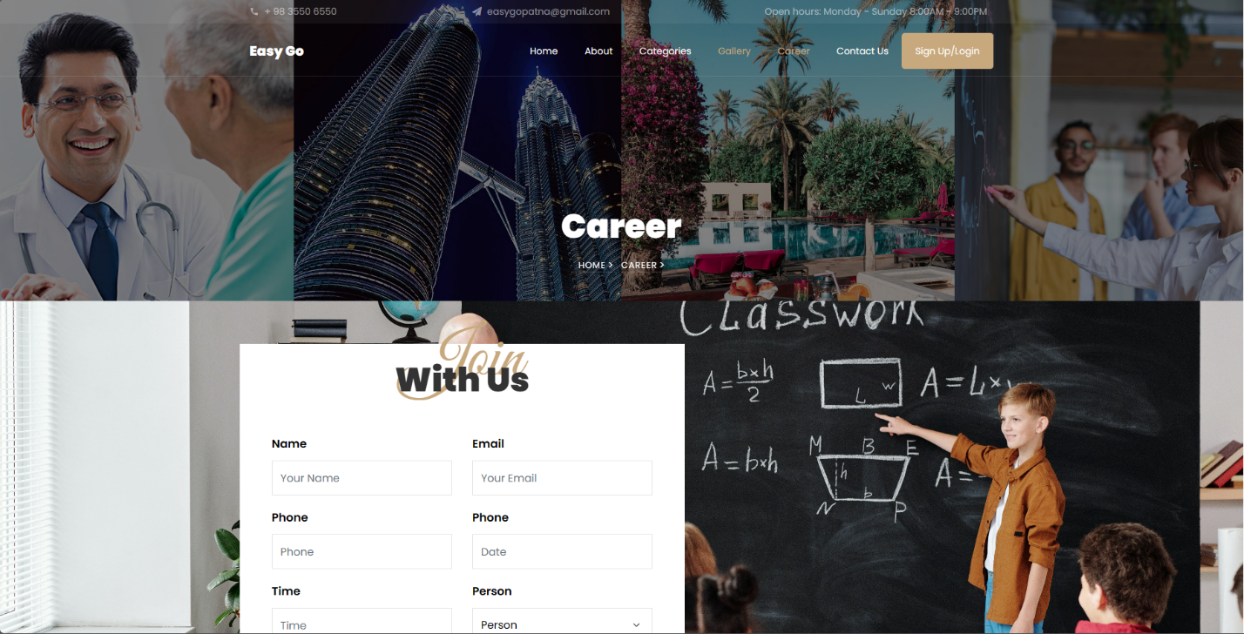

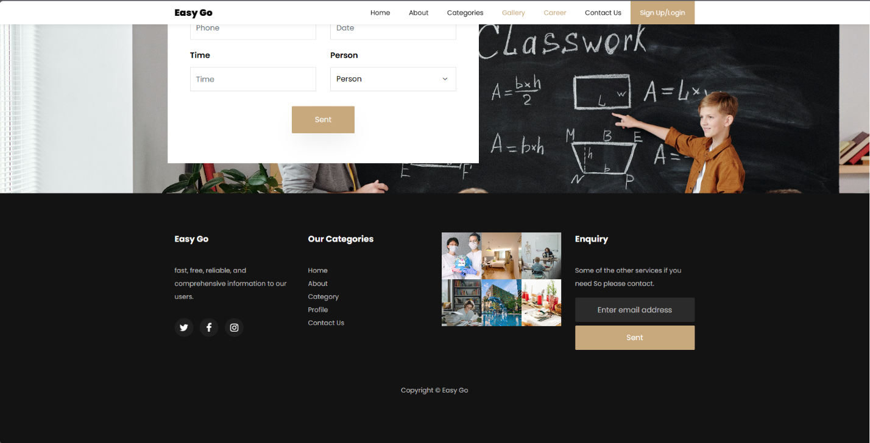

4.5 Figure: Career page of Easygo

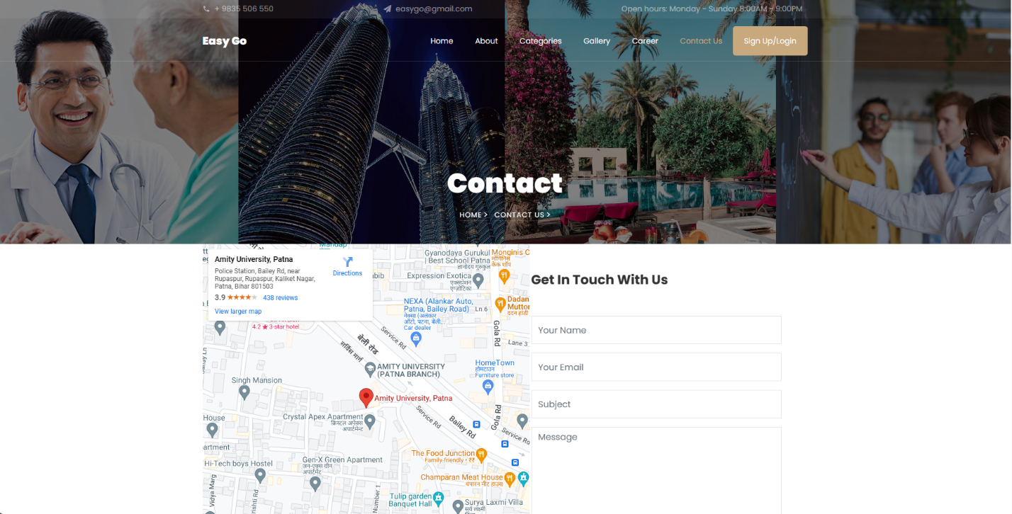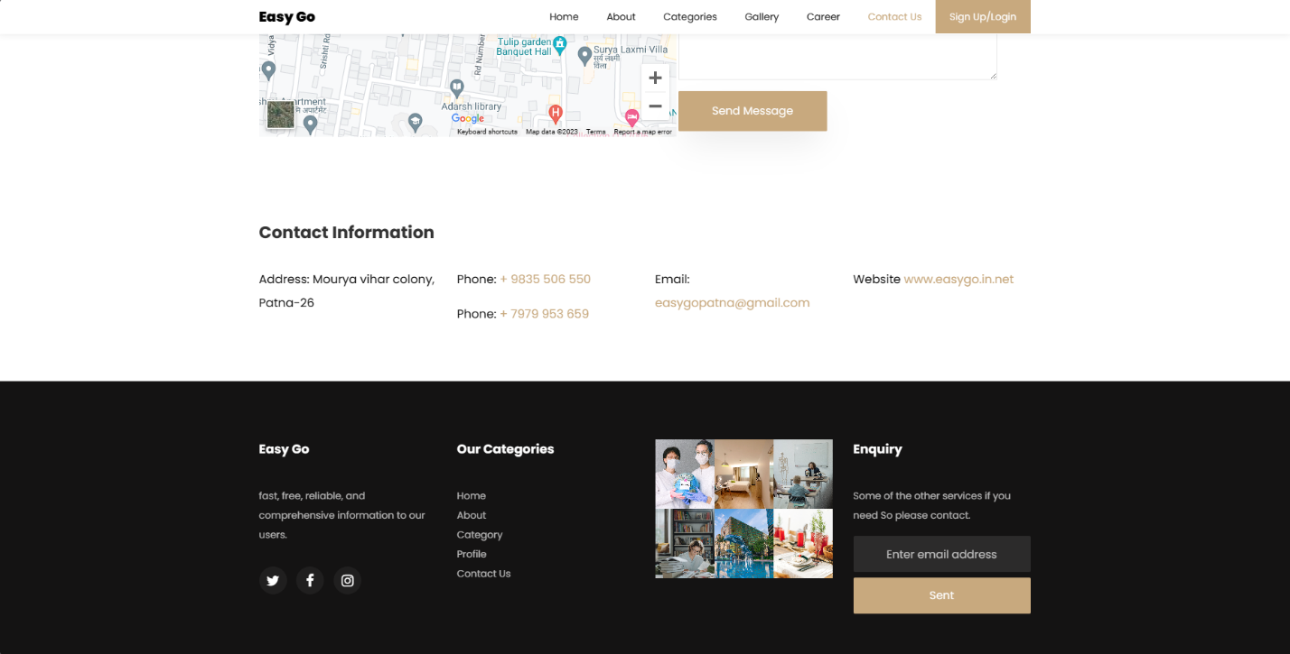

4.6 Figure: Contact page of Easygo

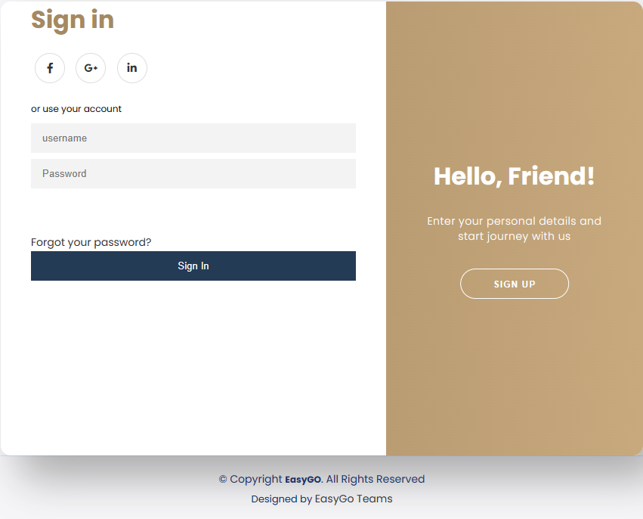

4.7 Figure: Login page of Easygo

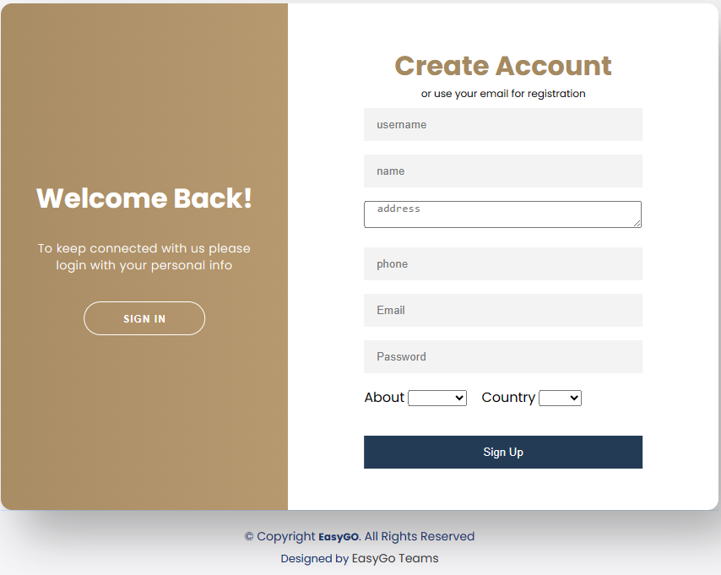

4.8 Figure: Registration page of Easygo

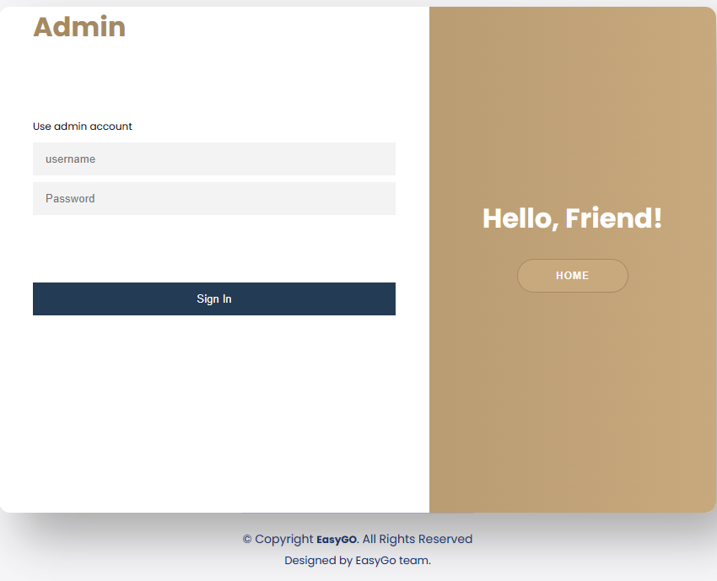

4.9 Figure: Admin Login page of Easygo

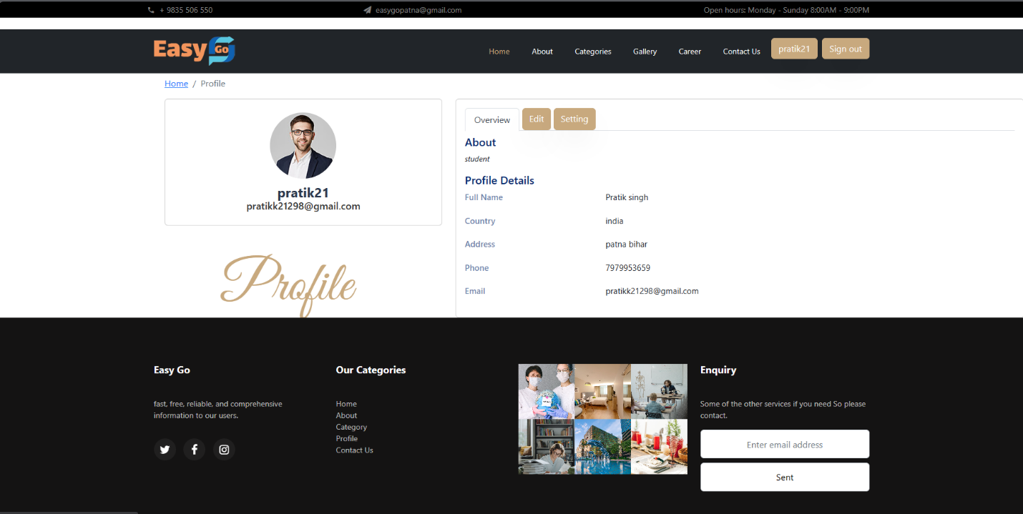

4.10 Figure: User Dashboard page of Easygo

Learning Outcomes from the Internship

* Significantly enhanced communication abilities through continuous interaction with the project guide and the team.
* Developed teamwork and workload sharing skills.
* Enhanced abilities in analysis and research.
* A crucial component was time management.

CHAPTER 5

CONCLUSION AND FUTURE ENHANCEMENT

5.1 CONCLUSION

In conclusion, the development of our Easy go inspired platform has been a journey marked by dedication, collaboration, and innovation. As a team, we set out to create a comprehensive solution that not only met but exceeded the expectations outlined in our project objectives.

Throughout the development lifecycle, we successfully translated our vision into a robust and scalable system architecture. The incorporation of cutting-edge technologies and a well-defined database design ensured the platform's efficiency and responsiveness, meeting the demands of our target audience.

Our commitment to user-centric design is evident in the carefully crafted user interfaces, which prioritize an intuitive and seamless experience for our users. The implementation of a modular system allowed for the efficient management of various features, ensuring flexibility and adaptability to future enhancements.

The testing phase, with its rigorous evaluation of each module and functionality, provided us with the confidence that our platform not only meets the functional requirements but also adheres to the highest standards of security and performance.

As we move forward, we recognize the importance of a robust maintenance and support plan to ensure the longevity and success of our platform. Ongoing collaboration and communication will be vital in addressing user feedback, implementing updates, and proactively managing any potential challenges.

This project has not only added a valuable asset to our portfolio but has also equipped us with invaluable experience and insights into the complexities of developing a comprehensive local search platform. We extend our gratitude to the entire team for their hard work, dedication, and collaborative spirit throughout this endeavor.

In the ever-evolving landscape of technology, our Easy go-like platform stands as a testament to our commitment to innovation and excellence. We look forward to the continued success and growth of our platform, confident that it will make a significant impact in connecting businesses with their local communities.

5.2 FUTURE ENHANCEMENT

Identifying potential future enhancements for an Easy go like platform involves considering user feedback, emerging trends in technology, and opportunities for improvement.

Develop a dedicated mobile app with features optimized for mobile users.

Adding an Admin dashboard in the Web application to control the data more efficiently.

Create a categories function to provide businesses with more detailed analytics and insights into user interactions with their listings.

Allow users to log in or sign up using their social media accounts.

Implement real-time chat features between users and businesses for immediate inquiries.

Explore the integration of chatbots to handle common queries and provide instant assistance.